|  |  |
| --- | --- |
| **Embedded System Project**  *[EE3401]* | **Devendra Pratap Rao**  **121EE0357**    **Dhruv Shaswat**  **121EE0841**  **Rinku Nogiya**  **121EE0345**  **Submitted to**  **Prof. Supratim Gupta** |

GAS LEAKAGE DETECTION SYSTEM USING 8051 MICROCONTROLLER

***Abstract:*** Nowadays, Gas leakage has turned out to be a major problem with the industrial sector as well as households. The report has been stipulated in order to ensure that the supervisor of the gas plants or the owner of the household is notified of the gas leakage which has occurred and at the same time buzzer will alter to the concerned person. This report holds even more relevance in the current pandemic situation because industries are facing paucity of workmen due to social distancing norms and such a system would enable them to aware of any mishaps at the industrial site.

1. **Introduction**

We designed a system which essentially detects LPG leakage and emphasis by measures such as Buzzer sound, LED Blink. This prototype turns out to be price effective and has a high degree of accuracy. In this system we are using 8051 Microcontroller as our host. It is connected to four other modules: MQ2 Gas sensor, Buzzer, LED pins, Relay on one side of the gas sensor are connected to the power supply. On the other side one of the pins is connected to the analog input of the microcontroller and the other two pins are connected to the ground. The remaining modules are connected to the output pins of the microcontroller. In recent families, the use of LPG has taken over again and accident cases due to LPG are increasing. From the use of piping cylinders, a serious safety threat as well costs. Our prototype will be a blessing to many homes as it is saving.

## Literature Review

The safest way to detect gas leaks and to remove gas before burning. In this study, a gas leak detection model and a transport system are introduced. The researcher had used a 8051 MC-based system, wherein the system activates buzzer when gas leaks are detected, closes gas supply the solenoid valve stops the further gas leakage and also removes the gas by changing the evacuator fans. Ensuring that the occupant of the household is informed suitably in case of gas leakage.. The user has also been provided with the privilege to remotely monitor the test environment by sending necessary codes.

Another fact that gas leaks are a major problem in the industrial sector, residential areas and also gas-powered vehicles such as CNG cars and buses. The aim of this paper is to build such a machine that can automatically detect and stop gas leaks in those areas where they can. The system detects LPG (Liquefied Petroleum Gas) leaks using a gas sensor and buzzer to notify a person of gas leaks . When the concentration of the LPG in the air exceeds the pre-set level, the gas sensor senses a gas leak and the discharge senses it active low. This is detected by the microcontroller and the LED and buzzer are turned on simultaneously.

One way to prevent gas leaks is to introduce a gas leakage detection kit in high-risk areas. The purpose of this particular report was to introduce a design wherein user can automatically sense and prevent internal gas leaks in endangered areas. High sensitivity gas sensors for detecting propane (C3H8) and butane (C4H10). The gas leak system contains a LED i.e. warns by glow. However, the previous gas leak system cannot respond in time. This report provides design in both software and hardware.

In this particular report, proposed a rule that uses the flexible capsule of the MQ-2 nerves to measure the maximum concentration of methane and hydrogen respectively. This method involves mixing gas to be studied in a known air volume. Three methods are suggested and are compared in terms of coherence and duplication of values. The first method is performed in an airtight enclosed room, the second method consists of direct injection of a gas sensor placed in an open area, and the last method is achieved by direct injection of a gas sensor placed in a slightly closed capsule. Comparison analysis concludes that the first procedure yields excellent repetition, with a typical high deviation of 13.88% in the range of CH4 and 5.1% in H2. However, its proportion is weak (i.e. R 2 = 0.8637 for CH4 and -R 2 = 0.5756 for H2). The second method has better linearity but is poorly duplicated. The third method shows good results with values of R 2 of 0.9973 in the CH 4 and 0.9472 H values. The use of a slightly closed capsule has resulted in an acceptable line of nerve response up to 20% for CH4 and up to 13.33% of H2 concentration in the studied environment.

The aims to show what a microcontroller can look like one is hired to install a lot of external items at a time adding additional functionality at costs such as simplicity integrated components. In the report is going to meanwhile, hardware and microprocessor firmware have been around designed to use smart LPG alarm system (LPG stops Liquefied Petroleum Gas) for CNG and LPG automobiles so as to create an alert notification before any unwanted mishap.

# METHODOLOGY

Figure 1 displays our design of gas detection using 8051 MC. It clearly displays all the interfacings that are attached to the central unit (8051 MC), which processes all the data it has received and gives the alert feedback in different forms.

Here, we have interfaced Led and Buzzer for generating the public alert when the gas leakage has been detected by the system. Relay module interfaced with MAIN power had been used as a safety precautionary measure in the case of gas detection because malfunctioning of any circuitry line, during the event of leakage can cause fire which can worsen the situation more. At times, they may even lead to a wild explosion due to vigorous reaction of gases like LPG Gas (propane, butane) with the fire. In order to hold the situation under control, relay module (acts as a circuit breaker for the main power supply) had been turned off during the gas leakage.

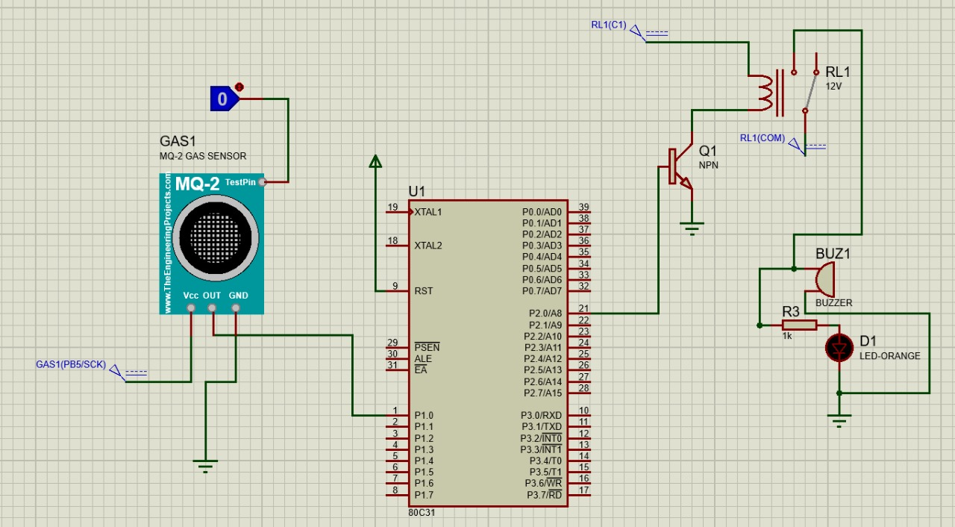

**Figure 2:** Schematic of the proteus design (inactive)

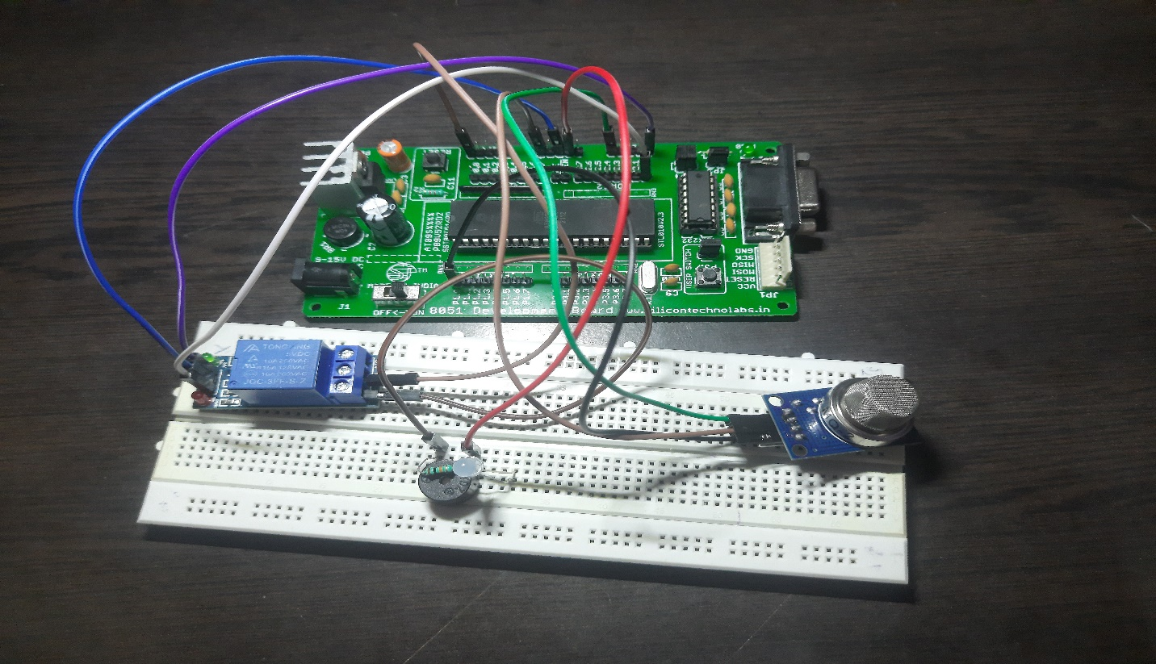

**Figure 3:** Hardware design of Schematic (inactive)

**Table 3.1**: Components interfaced

|  |  |  |
| --- | --- | --- |
| **Sensor name** | **Pins** | **Functionality** |
| MQ2 (GAS) sensor | Pin 1.0 | Gas detection |
| BUZZER | Pin 0.0(Synced with Relay) | Alarm |
| JQC 3FF Relay | Pin 2.0 | Low level TTL signals to High level  (for Relay operation) |
| LED series with Resistor (1Kohm) | Parallel to Buzzer | Display of alert generated |
| LOGIC ANALYSER | Test Pin (GAS) | Manual logic generation |

## Process flow

In Figure 3, the process flow of the Gas Detection System is clearly Illustrated, Initially the Modules (GSM, LCD, RELAY, MQ2 gas Sensor) will be initialized after Initialization of modules the output of Gas sensor is taken as Input by 8051 (Digital input) and checked with the condition given in Table 3.2.1.

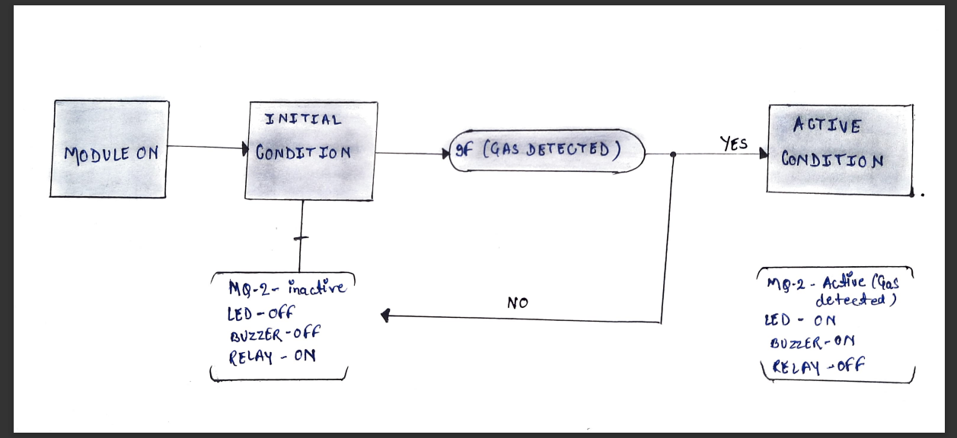

**Figure 3**: Block diagram of Gas Detection System (Circuit Connection)

**Table 3.2.1**: Alert Status

|  |  |  |
| --- | --- | --- |
| **Digital Output of Gas sensor** | **STATUS** | |
|  | Buzzer | Led |
| 0 | Off | Off |
| 1 | On | On |

If the alert is not generated:

* + 1. Buzzer is in OFF state
    2. Relay is ON (Electricity turned on)

If the alert is generated:

* + - 1. Buzzer is in ON state
      2. Relay is OFF (Electricity turned off)

# RESULTS AND DISCUSSION

## 4.1 Schematic of designed Proteus Circuitry

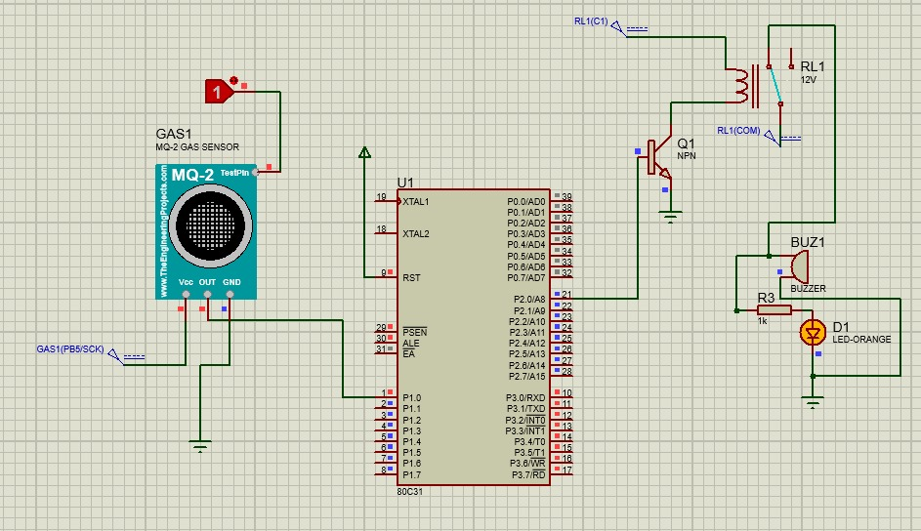

**Figure 4**: Schematic of the proteus design (Active stage)

Figure 4 represents the active state-1 of the circuitry, which means the entire circuit had been turned on with the supply from 8051 MC. Once, the circuitry is on module has been pushed to the initial state (i.e. No gas detected). Relay circuitry is turned on and that can be witnessed from the LED output attached with the relay circuitry. If the implementation of this idea is done in real time, the configuration of the system can be extended to a much higher level. If this is going to be an hardware implementation, we will be able to detect the exact level or amount (in PPM) of gas present in the surroundings. We can also set a threshold and compare the obtained values from the sensor with these threshold values in order to increase the accuracy of the system to a higher level. Because the vulnerability of accidents depends on the significant amount of gas detected. As we have made our design with a simulation-based platform, sensors can only output the digital values (either ‘0’ (not detected) or ‘1’(detected).

In that context we have attached the logic analyzer to the output pin of the MQ2 gas sensor. By default, the logic toggle is off. The above figure displays the simulation result of our design in proteus, when a gas had been detected. When the logic is turned on manually by the user, the design gets excited and the entire module starts with the process as per the flow process diagram.

So, whenever the logic toggle is activated, it means that the gas has been detected. In that case, LED and buzzer is enabled as the instant form of output sensed. Led attached to the relay circuitry changes the state from, on to off which shows that the main supply had been turned off when the gas had been detected.

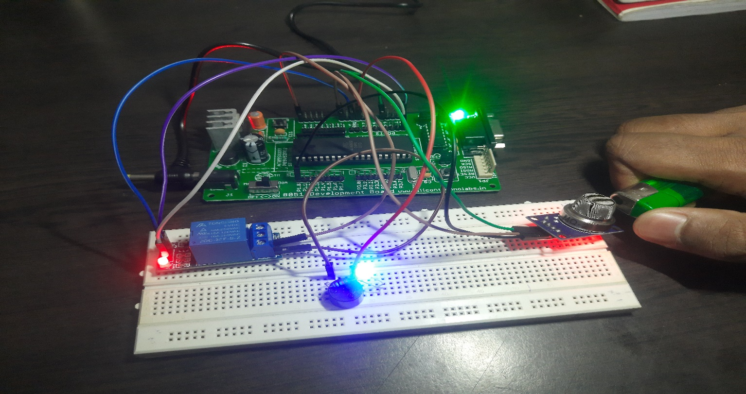

**Figure 5**: Hardware design of Schematic (Active stage)

The above figure **4 and 5** shows the schematic proteus design and hardware connection of our gas detection circuit. All the required interfacings have been done based on their need in the working of the circuit

**V. Assembly Language**

org 0100h ; Set the origin of the program memory to address 0100h

Start:

MOV P1, #01H ; Move the value 01H into register P1

MOV P2, #00H ; Move the value 00H into register P2

JUMP:

MOV A, P1 ; Move the value in register P1 to the accumulator A

CJNE A, #01H, JUMP ; Compare A with 01H; if not equal, jump to the label JUMP

CJNE A, #00H, CHECK ; Compare A with 00H; if not equal, jump to the label CHECK

CHECK:

MOV R3, #0FFH ; Move the value 0FFH into register R3

HERE1:MOV R2, #0FFH ; Move the value 0FFH into register R2

HERE2:MOV R1, #0FH ; Move the value 0FH into register R1

HERE: DJNZ R1, HERE ; Decrement R1 and jump to HERE if R1 is not zero

DJNZ R2, HERE2 ; Decrement R2 and jump to HERE2 if R2 is not zero

DJNZ R3, HERE1 ; Decrement R3 and jump to HERE1 if R3 is not zero

CJNE A, #01H, JUMP ; Compare A with 01H; if not equal, jump to the label JUMP

Loop:

MOV A, P1 ; Move the value in register P1 to the accumulator A

MOV P2, A ; Move the value in A to register P2

MOV A, P1 ; Move the value in register P1 to the accumulator A

CJNE A, #00H, Loop ; Compare A with 00H; if not equal, jump to the label Loop

;====================================================================

END ; End of the program

**Here's a summary of the code:**

Initialization:

Set the program origin to address 0100h.

Initialize registers P1 and P2 with values 01H and 00H, respectively.

Jump and Check:

Use a loop labeled JUMP to continuously check the value in register P1.

If the value in P1 is not equal to 01H, the program jumps back to the JUMP label.

If the value in P1 is not equal to 00H, the program jumps to the CHECK label.

Check Section (CHECK):

Initialize registers R1, R2, and R3 with specific values.

Use nested loops (HERE1, HERE2, and HERE) for delay.

After the delay, check if the value in register A is equal to 01H. If it is, jump back to the JUMP label.

Loop Section (Loop):

Copy the value in register P1 to register P2.

Check if the value in register P1 is not equal to 00H. If it is not, jump back to the Loop label.

End of Program:

The program ends.

Overall, this program seems to continuously check and loop based on the value in P1, and there is a delay section (CHECK) with nested loops. The exact purpose or function of this code is not entirely clear without additional context about the hardware and the intended application.

# CONCLUSION

The theme of the Report when merged with certain established embedded technologies can be quite effective in a number of industries which possess a large working population in their manufacturing industries. Finally, we conclude in recent households and industries the use of LPG is taking a big troll. From the use of cylinders to the use of petroleum pipelines in industries. The biggest threat in using this technology is security. And our prototype will prove to be a blessing for numerous production sectors.

A wide variety of gas leakage detections are available in the real time for surety implementation but all these methods come up with their own advantages and disadvantages. A wide variety of gas leakage detections are available in the real time for surety implementation but all this method comes up with their own advantages and disadvantages. Most are system are operational in external implementation through visual detection or portable based leakage detection but the detection time is very long. But the design that we have proposed using 8051 proved reliable, accurate as well as delay efficient in terms of detection, which will be a suitable choice for real time implementation.

# FUTURE WORK

This work is limited to the design of an efficient system for monitoring LPG leakage in a susceptible area, alerting the user and shutting down the gas supply using a microcontroller-based detection system. Future work can be a weighing scale (or its equivalent) be incorporated into the design to measure the amount of gas used or left in the gas tank or cylinder. Digital signal processing concepts can also be applied to the existing paper to extend the methodology further and be of extrinsic use to the industrial sector (gas plants).